Acoplamientos de Variables DECLARE

v_RoomID classes.room_id%TYPE;

v_Building rooms.buliding%TYPE;

v_Department classes.department%TYPE;

v_Course classes.course%TYPE;

CURSOR c_Building IS

SELECT building

FROM rooms, classes

WHERE rooms.room_id = classes.room_id

AND department = v_Department

AND course = v_Course;

BEGIN

v_Department := ‘HIS’;

v_Course _= 101;

OPEN c_Building;

v_Department := ‘XXX’;

v_Course := -1;

END;

/

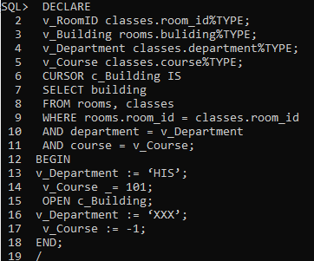

Cursores parametizados

DECLARE

CURSOR c_building (v_RoomID classes.room_id%TYPE;

v_Building rooms.buliding%TYPE;

v_Department classes.department%TYPE;

v_Course classes.course%TYPE) IS

SELECT building

FROM rooms, classes

WHERE rooms.room_id = classes.room_id

AND department = v_Department

AND course = v_Course;

BEGIN

OPEN c_building (‘HIS’,101);

END

/

